TotalSchool™ Management System

Proposal for

Your School


“Any time there is a change, there is opportunity.

So it is paramount that an organization gets energized rather than paralyzed”

-Jack Welch, General Electric

Contact

Adekanmbi Oluremi

eSofties Solutions Limited

Consulting and Outsourcing

Email: aremi@esoftiesnigeria.com

Mobile: 08098753155

Landline: 08191448976

©November 2010

Statement of Confidentiality

All information contained in this document is provided in confidence and should be treated as such by all parties. It shall not be used for any other purpose, and shall not be published or disclosed wholly or in part to any other party without the express written permission of eSofties Solutions limited, and shall be held in safe custody. These obligations shall not apply to information that is in the public domain, held on the Internet, or becomes known legitimately from some external source. All intellectual property rights of products or services provided by eSofties Solutions limited shall remain vested in eSofties Solutions limited.

This document, its contents and attachments are subject to contract.

All Registered Trademarks referred to are herewith acknowledged.

Page 2 of 34
Table of Contents

1.0 | Introduction------------------------------------------------------------------------------------------- |  |  | 6
 | 1.1 | Executive Summary – The TotalSchool™ Concept |  | ----------------6
 | 1.2 | Our Proposal--------------------------------------------------------------- |  | 7
 |  | 1.2.1 | Invitation to you------------------------------------------------ | 7
 |  | 1.2.2 | Proposition of the TotalSchool™ Package---------------- | 7
2.0 | Our Solutions-------------------------------------------------------------------------------------- |  |  | 11
3.0 | The Solutions-------------------------------------------------------------------------------------- |  |  | 12
 | 3.1 | eLearning-------------------------------------------------------------- |  | 12
 |  | 3.1.1 | eLearning Resources-------------------------------------- | 12
 |  | 3.1.2 | ICT Resource Center-------------------------------------- | 14
 |  | 3.1.3 | The Blended Learning Curriculum--------------------- | 15
 | 3.2 | Assets and Inventory Management------------------------------ |  | 16
 |  | 3.2.1 | Overview----------------------------------------------------- | 16
 |  | 3.2.2 | Features------------------------------------------------------ | 16
 | 3.3 | Test and Exam Results Management---------------------------- |  | 18
 |  | 3.3.1 | Overview---------------------------------------------------- | 18
 |  | 3.3.2 | Features------------------------------------------------------- | 18
 | 3.4 | PromptPay™---------------------------------------------------------- |  | 19
 |  | 3.4.1 | Overview----------------------------------------------------- | 19

Page 3 of 34
 |  | 3.4.2 | Features------------------------------------------------------ | 19
 | 3.5 | Student/Parent and Guardian/Staff Records Management------------- |  |  | 20
 |  | 3.5.1 | Overview------------------------------------------------------ | 20
 |  | 3.5.2 | Features------------------------------------------------------ | 20
 | 3.6 | Attendance Management ------------------------------------------------------ |  |  | 22
 |  | 3.6.1 | Overview------------------------------------------------------ | 22
 |  | 3.6.2 | Features------------------------------------------------------ | 22
 | 3.7 | Payroll | ------------------------------------------------------------------------------ |  | 24
 |  | 3.7.1 | Overview------------------------------------------------------ | 24
 |  | 3.7.2 | Features------------------------------------------------------ | 24
 | 3.8 | Finance Management Module----------------------------------------------- |  |  | 25
 |  | 3.8.1 | Overview------------------------------------------------------ | 25
 |  | 3.8.2 | Features------------------------------------------------------- | 25
 | 3.9 | iMessenger™--------------------------------------------------------------------- |  |  | 26
 |  | 3.9.1 | Overview------------------------------------------------------ | 26
 |  | 3.9.2 | Features------------------------------------------------------ | 26
 | 3.10 | Website and Others----------------------------------------------------------- |  |  | 27
 |  | 3.10.1 | Website-------------------------------------------------------- | 27
 |  | 3.10.2 | Others--------------------------------------------------------- | 27
4.0 | The Options---------------------------------------------------------------------- |  |  | 28

Page 4 of 34
Appendix-----------------------------------------------------------------------------------------------29

About eSofties Solutions Limited

Profile of Some eSofties Solutions Limited Key Personnel

What we have done in the past

Page 5 of 34
1.0 Introduction

The importance of information technology (IT) in education, whether it is used to support teaching and learning, or to develop student IT capability, or to support educational management, is now recognized throughout the world.

1.1 Executive Summary – The TotalSchool™ Concept

In our world today information technology is fast influencing how business is done and the ease with which one can do it. Transactions are now carried out across boundaries without any need for contact.

Nevertheless it is still a sore point to see how many businesses refuse to take advantage of this emerging trend in information technology. Furthermore a need to catch up with the rest of the world in information technology means providing or utilizing an educational curriculum that leverages on information technology.

A curriculum that leverages information technology such as the Blended Learning Curriculum is the perfect fit for this purpose. The Blended Learning Curriculum combines normal day to day classroom teaching with real world computer mediated or assisted learning (e-Learning) to foster an effective teaching and learning process. It does not aim to discard your current curriculum but instead enhance it by providing a total learning experience.

The Blended Learning Curriculum recognizes that certain concepts in daily classroom learning can be difficult to pass across especially when it involves abstract concepts as observed in the sciences and mathematics, so it utilizes e-Learning resources to fill up this learning gap thereby creating an effective teaching-learning process for the teacher and superb learning experience for the learner.


Classroom Learning e-Learning Simulated Practice



The Blended Curriculum

Having an e-Learning assisted or aided curriculum is wonderful but other aspects of a school, such as student records, school fees payment, performance notification and a host of other school processes

Page 6 of 34

are still being done manually by the school. Thus, for any school that wants to compete favorably in the future automating all these processes and more will be highest on their priority list.

The Blended Learning Curriculum and School automation system is introduced to your school as TotalSchool™. TotalSchool™ is a complete package meant to take care of your schools needs from aiding in smooth school administration to effective learning.

TotalSchool™ is a pioneering effort of eSofties Solutions Limited which is known for excellence and commitment to deliver unique and world class solutions. TotalSchool™ is aimed at automating the entire school process coupled with providing a sound information technology curriculum which is delivered by qualified and experienced teachers that have been trained to suit the learning needs of students’ right from Kindergarten to Junior Primary through to Senior Secondary.

The objectives of the TotalSchool™ program will mainly be to:

- Provide state of the art IT Resource Center for Schools.

- Provide eLearning opportunities for the child.

- Provide a world class integrated IT curriculum and learning environment.

- Store, Retrieve, Update and Create Reports on any student at the click of a button.

- Provide a student performance notification engine.

- Provide a test/ exams results management system.

- Provide an engine that allows the school maintain their school account but allow payments to be made from any bank.

- Provide a payroll management system.

- Provide a website for the school.

1.2 Our Proposal

1.2.1 Invitation to you

To create an Integrated Learning Environment for your school we invite you to take advantage of this opportunity and make your school a leader in Information Technology and Information Technology Education for your student and staff.

1.2.2 Proposition of the TotalSchool™ Package

TotalSchool™ is a complete Information Technology package that covers all aspects of the school as highlighted below

Page 7 of 34

- e-Learning – E-learning which is essentially the computer and network-enabled transfer of skills and knowledge with applications and processes which include Web-based learning, computer-based learning, virtual classroom opportunities and digital collaboration will be provided for your school. Content will also delivered via the Internet, intranet/extranet, audio or video tape, satellite TV, and CD-ROM. It can be self-paced or teacher-led and includes media in the form of text, image, animation, streaming video and audio.

- Resource Centre – We understand that the cost of putting together a state of the art IT resource center is quite expensive so we will provide the resource center at a point provided within the school for no initial capital. The Resource Center will be complete with projectors, internet facilities and e-learning capabilities.

- IT Curriculum – Producing a capable generation of IT versatile professional requires us to start with the younger generation, so we have carefully constructed a comprehensive IT curriculum that is designed specifically for the younger generation. International certifications are also introduced to them at this stage also.

- Assets and Inventory Management – To allow the school managed their assets and keep an inventory of their resources we have a solution that could easily be used to manage the library and the bookshop bundled into one. This solution allows the calculation of depreciation on assets and a host of other sophisticated features.

- Test and Exam Results Management – This area will also be automated to allow automatic generation of continuous assessment results/ end of term report cards, transcripts, academic summary of a student or of the school at a glance and a lot of other academic reports as needed by the school from time to time.

- PromptPay™ – We will provide a payment solution that allows your schools have an account with any bank and the parent/ guardian can still pay into this account from any banks’ branch or location of their choice. These payments reflect in your account real-time with receipt generation at that point of payment or by the school. Because we also know that you want to monitor your account instant notification and daily end-of-day summary report is also available for you.
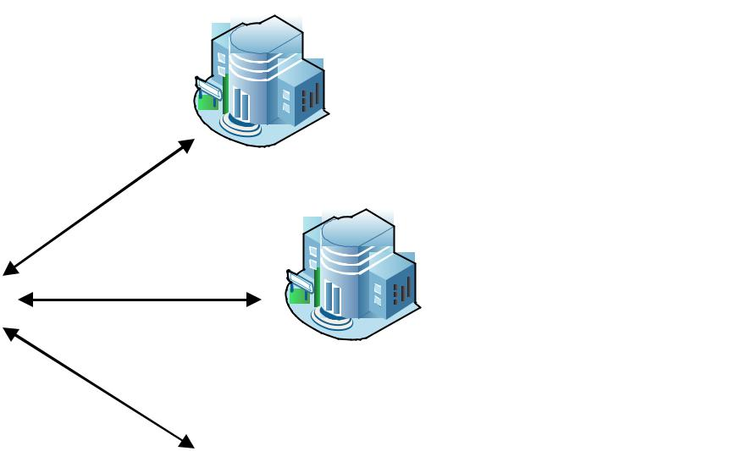

Bank A

Parents and
Guardians can
^{Bank B} walk into any

bank of choice
PromptPay™
and pay. No

restrictions!

Page 8 of 34

School has an account | Bank C
with a single Bank

- Student/Parent/Staff Record – For ease of storage and retrieval student details are mostly divided into three i.e. Student and Parent/ Guardian Details, Academic History and Payment History. All this details are stored in different files and a request for any of these details will mean a lookup of which files contain what and where to find such files.

Our Students Record solution allows you access to all these details together at the touch of a button. Other features of this Student Records software are generation of Reports which include any statistics on students, academics, payment history, general school academic performance etc


Manual Students Record Retrieval

Computerized one touch access to student details

- Attendance Management module – This module has two models. One of the models is based totally on software and the other module is implemented using cards that could be swiped at the point of entry for auto-notification.

- Payroll – The payroll software manages all aspect of administrative duties in staff payroll including computing salaries and remunerations on a wide variety of computations. This payroll software allows you add and remove staff, automatically compute benefits, control contract staff payments and more.

- iMessenger™ – Notifying a parent/guardian periodically of the performance of his/her wards will be a welcome facility that any school can provide for parents/guardians as this saves them from the trips that they otherwise have to make to the school at a time that is only justified because of the love the parent has for the child.

Page 9 of 34

With our Notification engine the school can notify any number of Parent/Guardian for any reasons at all which will include academic performance, school programmes, reminders etc


 |  | Chat | Instant notification of
 |  |  | Parents and Guardians
 | iMessenger™ | Email | about any school
 | iMessenger™ |  | activity ranging from
Student |  |  | activity ranging from
Student |  |  | student performance to
Information |  | SMS | student performance to
Information |  | SMS | reminders etc



- Website – To make your school easily available to the entire world, we will build a website for your school and if your schools’ website already exists we will assist with upgrading it so that information about the school can be easily disseminated.

Page 10 of 34
2.0 Our Solutions

The following is a list of our solution bundled together in the TotalSchool™ package.

- eLearning

- ICT Resource Centre

- Assets and Inventory Management

- Test and Exam Results Management

- PromptPay™

- Student/Parent and Guardian/Staff Records Management

- Attendance Management

- Payroll

- Finance Management Module

- iMessenger™

- Website and Others

We understand that your school might require the solutions separately so we allow picking of some of the solutions based on the needs of the school. All modules are built independently off one another.

Page 11 of 34
3.0 The Solution

To give a better understanding of what each of the solutions offer, we present an overview and feature of each of the solutions along with screenshots of some of the solutions.

3.1 eLearning Content

E-learning which is essentially the computer and network-enabled transfer of skills and knowledge with applications and processes which include Web-based learning, computer-based learning, virtual classroom opportunities and digital collaboration will be provided for your school. Content will also delivered via the Internet, intranet/extranet, audio or video tape, satellite TV, and CD-ROM. It can be self-paced or teacher-led and includes media in the form of text, image, animation, streaming video and audio.

3.1.1 eLearning Content

The following are screenshots of some of our content.
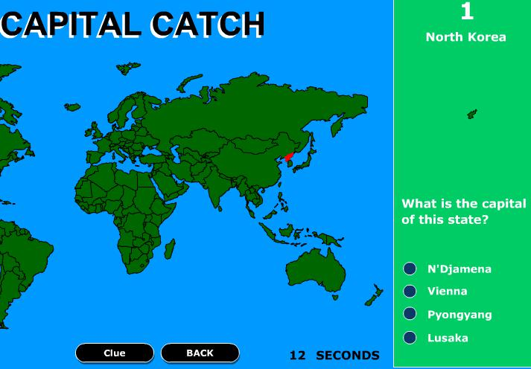

Page 12 of 34
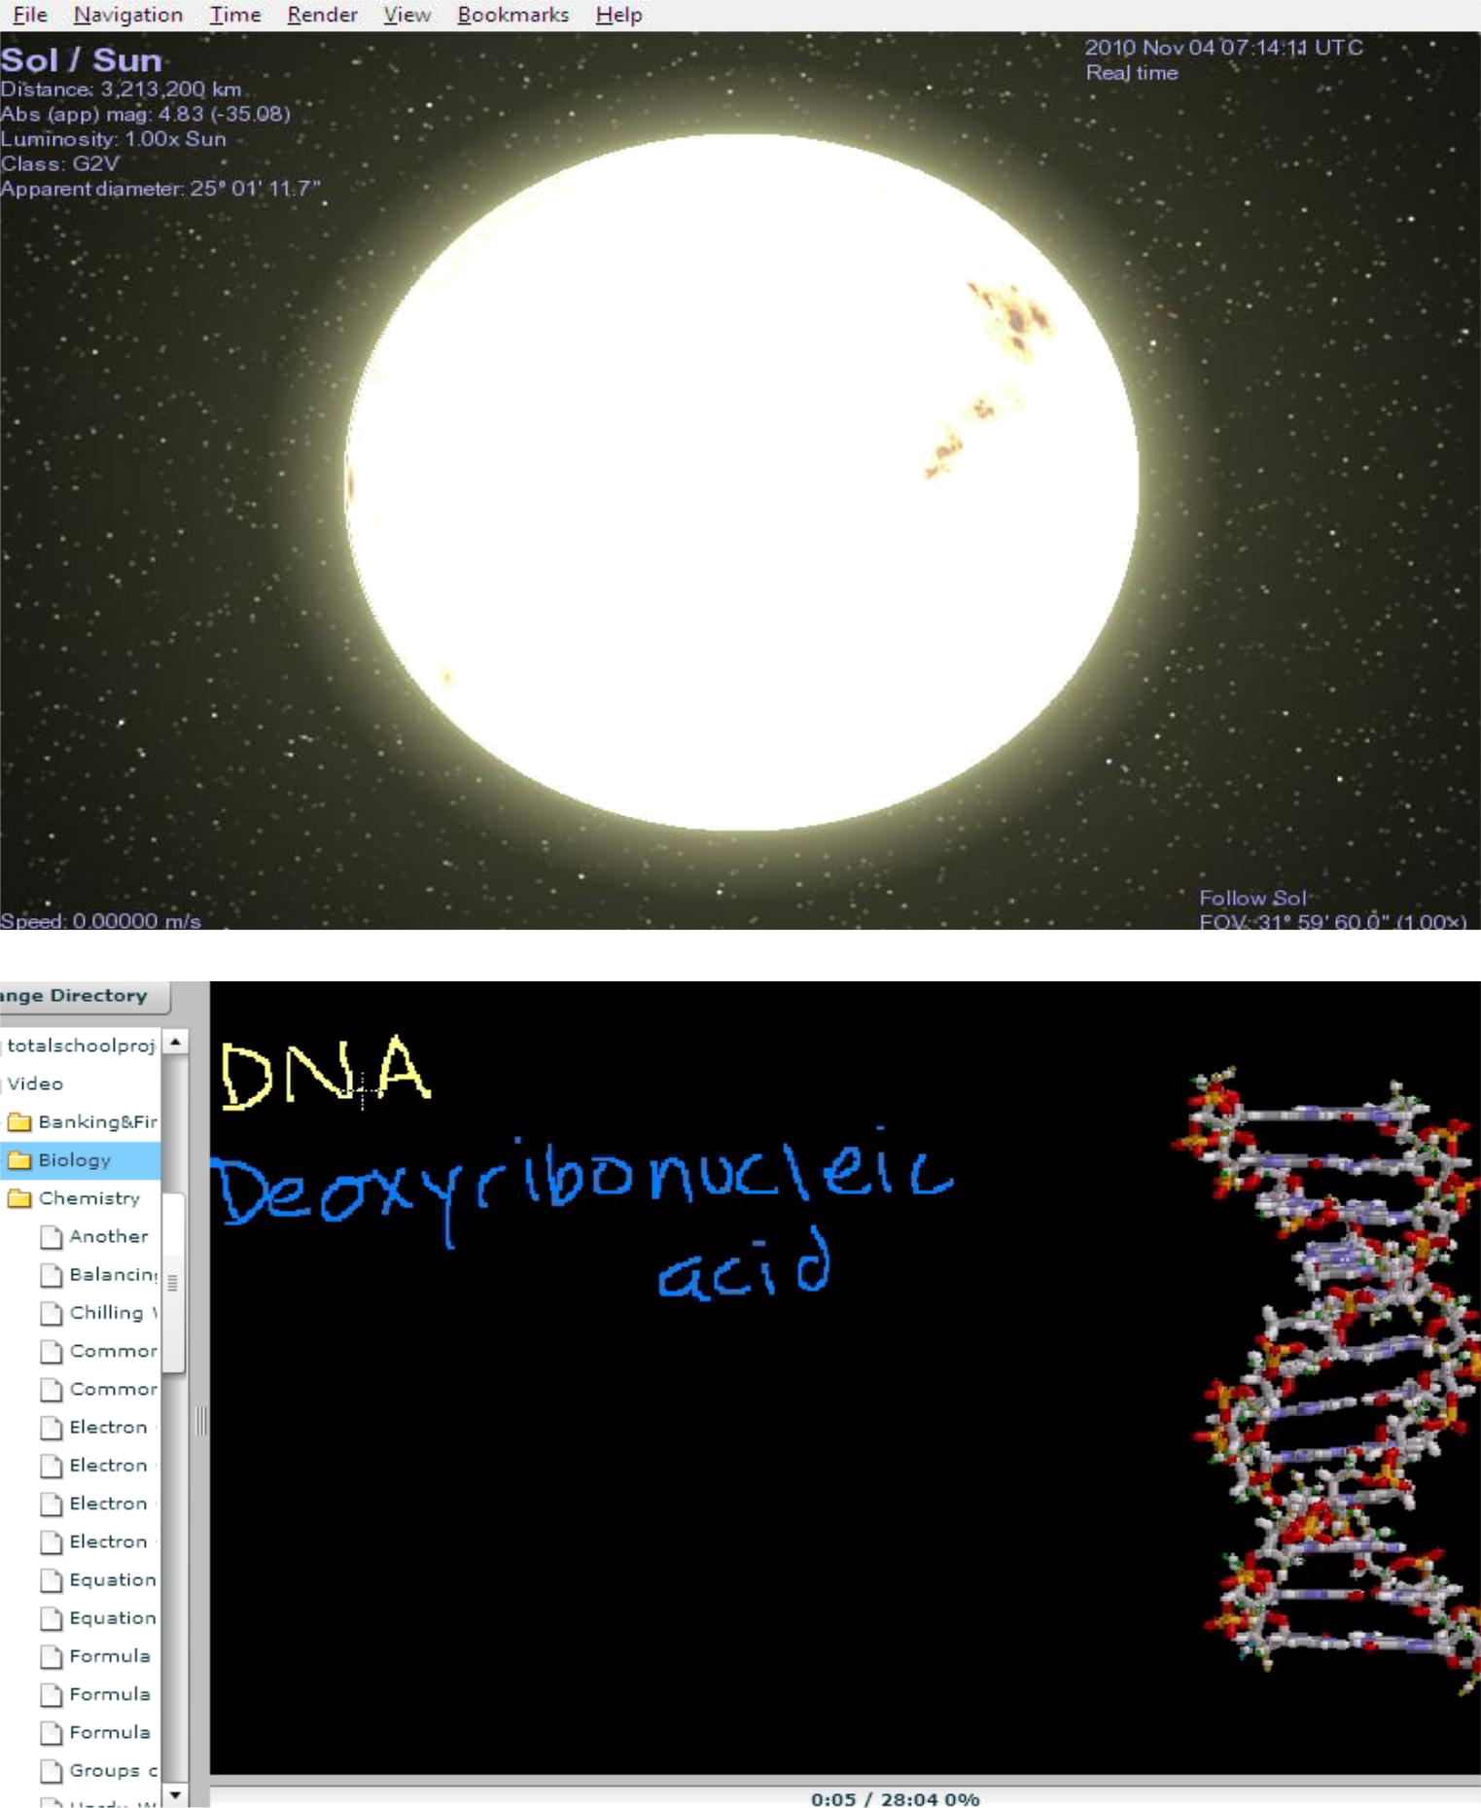

Page 13 of 34
3.1.2 ICT Resource Center

We understand that building a state of the art Resource Centre might be an expensive project to undertake, so we will provide a Resource Centre that comes complete with brand new computer systems, projectors, internet facilities and that is eLearning ready. This Resource Centre will be built such that its uses will not be limited to classroom teaching but can easily be adapted to a wide variety of purposes that include Parent-Teachers meeting, School programmes and a host of other activities.

The following picture shows a typical view of our Resource Center
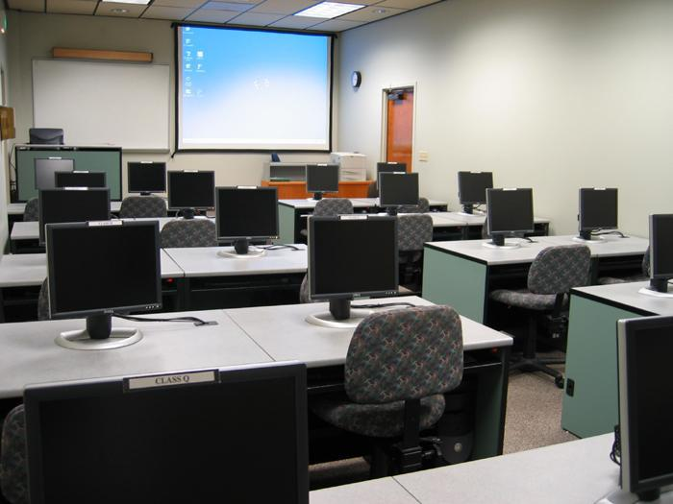

Page 14 of 34
3.1.3 The Blended Learning Curriculum

We also want to introduce to your school the Blended Curriculum which does not seek to discard your current curriculum but instead fosters it by using materials that expose the students to experiences that increases their understanding of concepts learnt in class particularly in the sciences.

We also have an IT curriculum designed by our team of experts specifically for children in classes from Kindergarten straight through to Higher Secondary School. Our curriculum of IT courses is delivered by trained IT instructors to ensure effective learning. Some of the courses in our curriculum are tailored towards various international certifications.

Page 15 of 34
3.2 Assets and Inventory Management

3.2.1 Overview

The Assets and Inventory Management module takes control of all issues relating to the assets of the school, it answers the following question at a glance

- Who borrowed what?

- Where is a particular asset?

- Who has borrowed which asset in the past?

- Is an asset due for collection?

This module will seamlessly integrated into the management of your school’s Library and Bookshop, helping you prevent fraud and loss of items that are precious to the school

3.2.2 Features

The features of the this module are listed as follows

- Depreciation calculation

- Capture of information about assets

- Asset allocation details at a glance

- Generation of reports about various activities carried out on the assets.

Here are some screenshots of the Assets and Inventory Management Module

Page 16 of 34
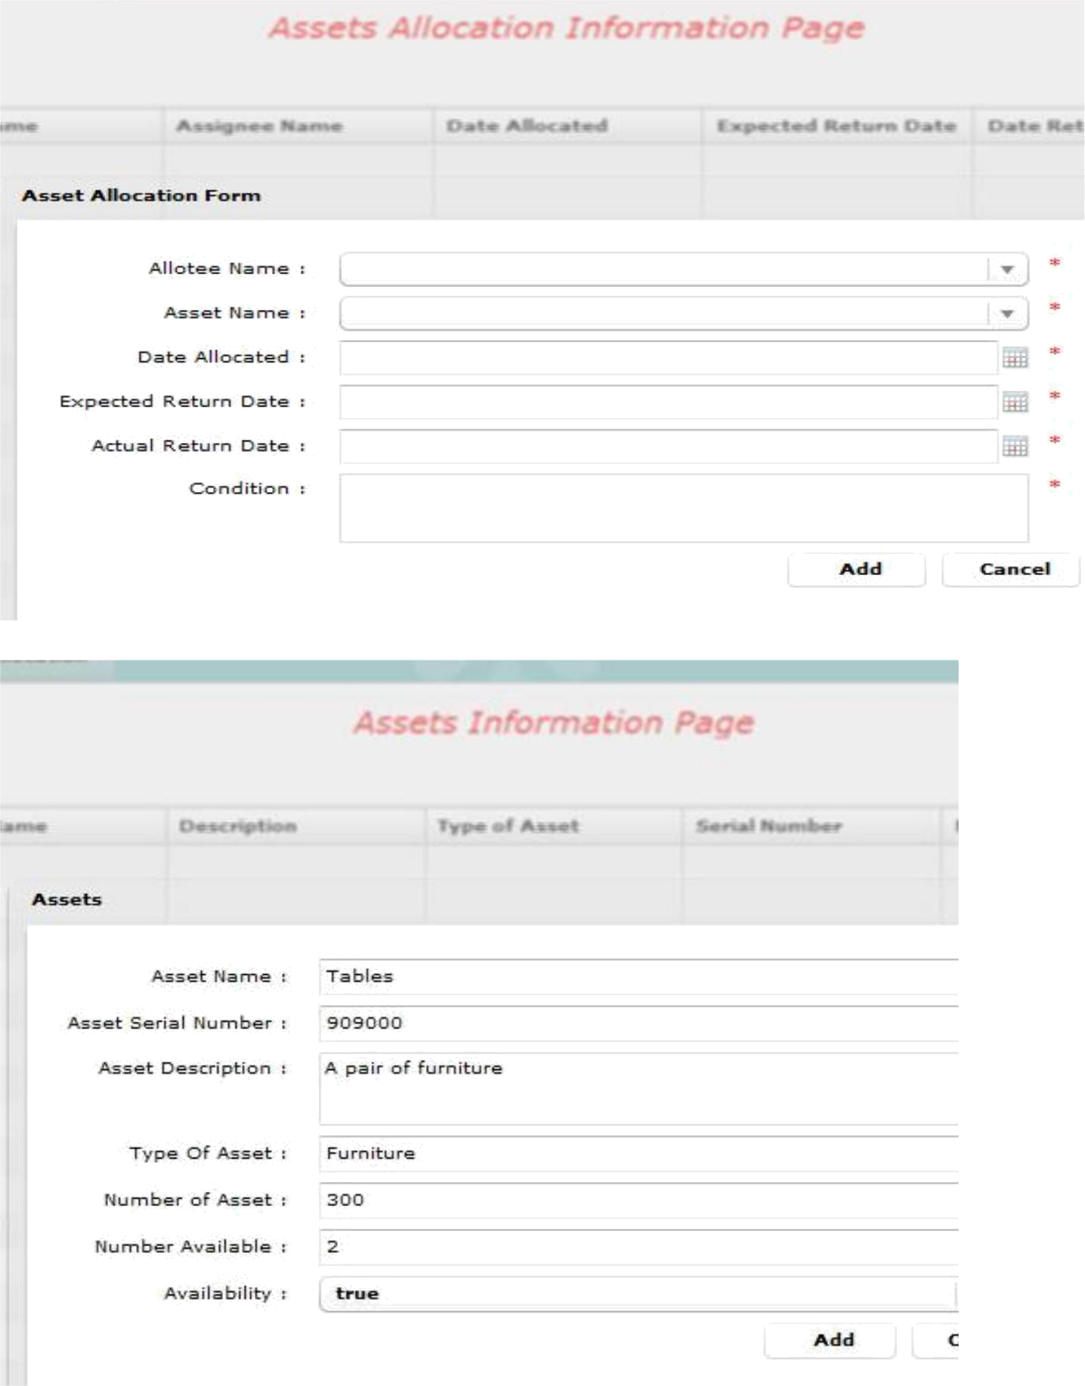

Page 17 of 34
3.3 Test and Exam Results Management

3.3.1 Overview

Managing the Continuous Assessment of students as never been easier with this module that only

requires that you enter the results of various students and it generates all the reports that you could

ever require including customized school mid-term and end to term results. Transcripts for students can

also be easily generated as well as academic history of the school which could then be used for

statistical purposes or as required by the school

3.3.2 Features

The features of this module are as follows
- Capture of student results

- Configuration of standard test scores fully flexible

- Generation of report cards, academic history of school and students etc

- Easily plugs into iMessenger™ for student performance reporting.

Here is a screenshot of this module.
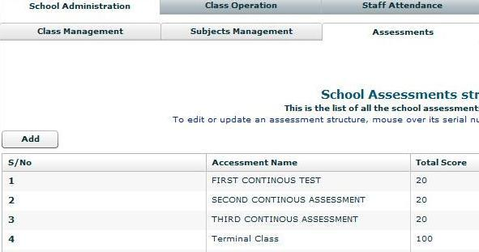

Page 18 of 34
3.4 PromptPay™

3.4.1 Overview

PromptPay™ is a payment solution that allows Parents and Guardians the luxury of making payments to the school in any Bank of their choice while the school still gets their money in the same account or in one account maintained by the school in another bank. Payments could still be split down for the school if you want the money split into several accounts.

Notifications on all payments will be sent to the school as well as an end of the day summary of payments. Another super feature of this solution is its ability to generate receipts and invoices at the point of payments or by the school. These invoices and receipts are of course customized for the school.

3.4.2 Features

The features of PromptPay™ are stated as follows

- Payments could be made in any bank and all payments funneled to a single account maintained by the school.

- End of day summary of payments

- Notification of payments

- Generation of reports to view all payments and detect defaulters

Page 19 of 34
3.5 Student/Parent and Guardian/Staff Records Management

3.5.1 Overview

The Student/Parent and Guardian/Staff Records Management module consist of components that allow the schools manage the details of Students, Parent and Staff. This module allows one click access to student information as well as allowing different kind of search based on different criteria to be carried out on students’ details that have already been captured and stored.

3.5.2 Features

The features offered by this module is listed as follows
- Capture of information of Student, Staff and Parents/Guardians

- Generation of reports various reports.

- One click search of information on any of them

The following are screenshots of this module
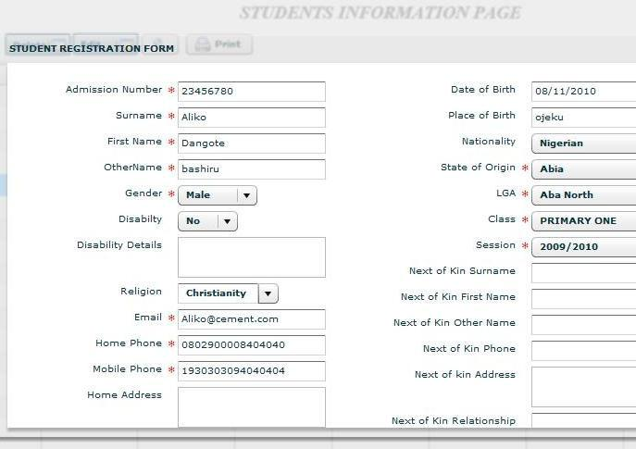

Page 20 of 34
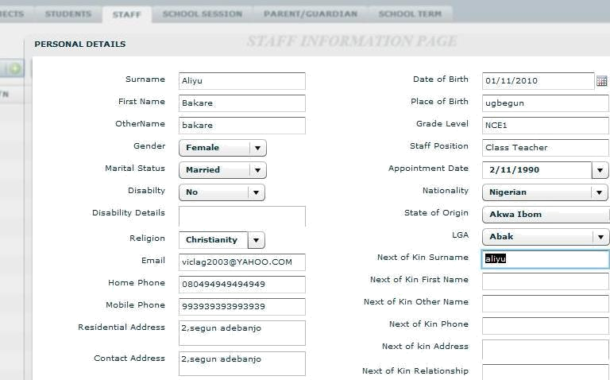

Staff Information capture page

Page 21 of 34
3.6 Attendance Management

3.6.1 Overview

This module has two implementations and each is based on the choice of the school. The first implementation is purely software based and it involves the capture of attendance information of Staff as well as students. It contains automatic time capture, so there is no issue of time change by any Staff or student.

The second implementation is card based and it involves the swiping of cards at the point of exit and entry specified within the school premises. Both solutions however have a reporting mechanism that alerts on late comers or unauthorized access.

3.6.2 Features

The Attendance Management Module has the following features
- Automatic time capture

- Alerts on late coming, unauthorized access etc

- Assessment computation made available to appropriate modules if they have financial

implications.

Here are some screenshots of the software based module

Page 22 of 34
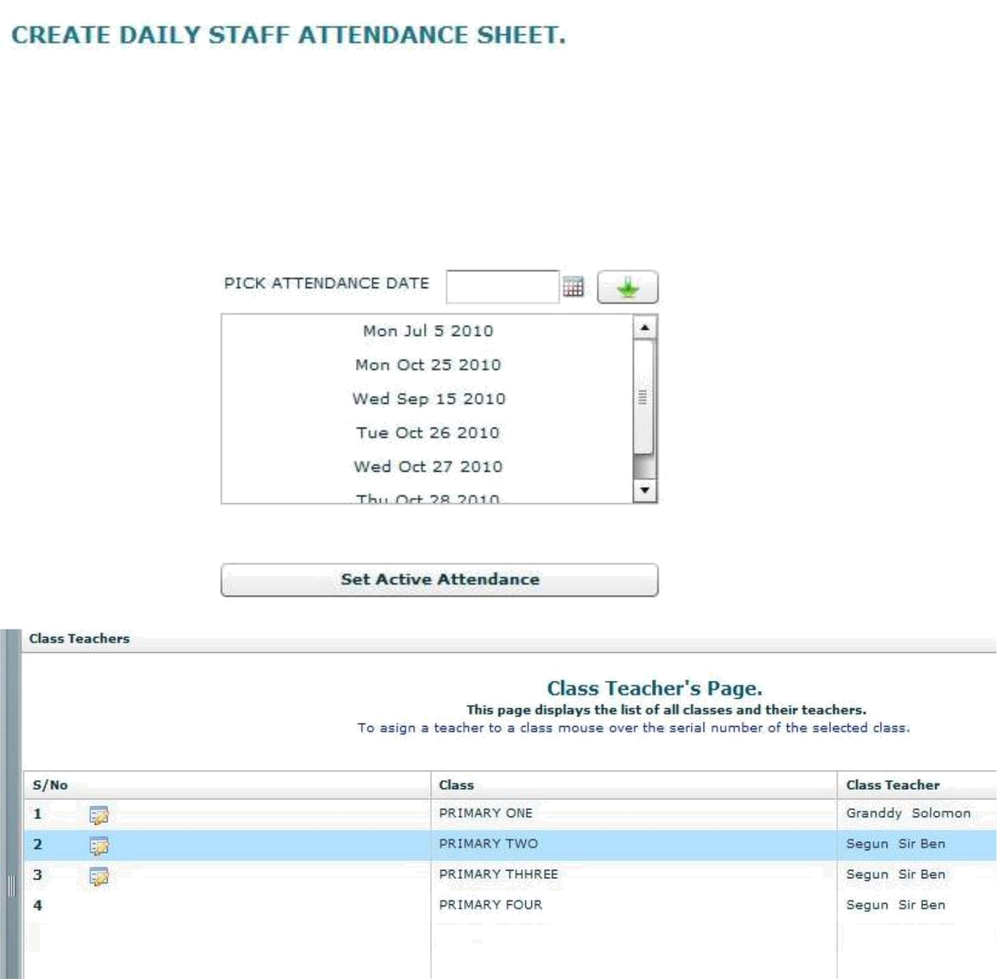

Assigning a teacher to a class for attendance taking

Page 23 of 34
3.7 Payroll

3.7.1 Overview

With our Payroll, flexible, cost-effective in-house payroll management has never been easier. This comprehensive, easy-to-use solution includes all the payroll functionality needed by midsized and larger organizations to process payroll accurately and quickly, every time. The robust functionality of Payroll makes it easy to produce pay slips on demand, run trial payrolls, and make last minute changes with no hassle. It’s easy to meet the needs of your unique organization with flexible features, including unlimited earnings, taxes, deduction types, multiple user-defined pay groups, and customizable events. 3.7.2 Features

The features of our Payroll module includes but not limited to
- Payroll allows you to create unlimited custom reports to meet the unique needs of your organization.

- You can enter data for multiple companies, pay groups, and employees to accommodate work situations not based on the standard salary structure. And then generate payroll for each of them or all of them.

- Payroll has a scheduler that determines when the Transaction Manager will be activated. This Scheduler can also be relived or stopped permanently. It also has the capability pf calculating arrears that accrued

as a result of the relief operation.
- Allows users to create multiple salary structures.

- Export all report data to external file. The supported format includes Microsoft Word, Microsoft Excel, PDF, XML, CSV.

Page 24 of 34
3.8 Finance Management Module

3.8.1 Overview

The school carries out transaction on a day to day basis and sometimes these transactions are prone to errors and fraud. Our Finance module handles all the transaction details of a school including synchronization with PromptPay™ to harmonize all the payment details of the school. It contains a feature that automatically assigns the login name of anybody that logs in to the transaction carried out in the application so that there is no question about who carried out a transaction or recorded a transaction.

3.8.2 Features

The features of the finance module are stated as follows
- Synchronization with PromptPay™

- Auto attachment of transactions to logged in user

- Capture of Financial information

- Configuration of school fees details per class per term and session. Here is a screenshot of the Finance Module
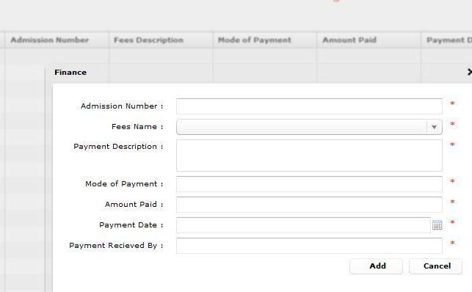

Page 25 of 34
3.9 iMessenger™

3.9.1 Overview

This module was originally designed to allow the notification of Parents/Guardians about student performance in school activities but it can still be used to send reminders, notice of school activities and a host of other notifications.

This module comfortably plugs in to the other modules which need information to be sent out to anybody.

3.9.2 Features

The features are as follows
- Ability to send messages in three channels i.e. SMS, Email and Chat

- Ease of plug-in to other modules.

Page 26 of 34
3.10 Website and Others

3.10.1 Website

We will build a website for the school (where the school does not have any) or assist in the upgrade of an existing website so as to be able to disseminate information and allow content to be provided for the users and visitors of the website.

3.10.2 Others

From time to time in a school that has our presence, we will organize termly programmes such as Visits to places that enhances learning, IT weeks, Prize Giving days and a host of other programmes.

Page 27 of 34
4.0 The Options

We understand that your school may not require all these solutions as a single package so we offer you a chance to pick out of the solutions as they fit your need.

We allow payments for any combination of solutions in two different models

- Down payment for any solution/combination of solutions or

- Payments made as technology fee by students over a period of time as agreed by both parties.

For more information please do not hesitate to call us for a further presentation on all of the solutions or better still the solution which you have selected.

Page 28 of 34
Appendix:

About eSofties Solutions Limited

eSofties Solutions Limited is one of Nigeria’s leading providers of training and outsourcing solutions and has grown into a premier information technology (IT) training and outsourcing company offering a diversified range of services to the government and private industry. We also have a track record of providing robust and scalable enterprise applications that deliver a complete solution and not just a part of the whole.

Core to our organization’s focus, is to enhance our customers' business by providing the highest quality IT products and services possible. Our customer support strategy is based upon total, no-compromise customer satisfaction and we will continually strive to offer a complete package of up-to-date value added solutions to meet our customers'.

eSofties Solutions Limited continues to grow in the competitive information technology market by offering broad-based experience; a stable, dedicated, and knowledgeable staff; and a commitment to finding innovative and cost effective solutions to our customers’ technology and business needs.

We maintain our corporate headquarters in 15A, Ikorodu Road, Behind Maryland BRT Bus stop, Opposite Kresta Laurel Complex, Maryland, Lagos. Our clients range from financial and multinational institutions to family-owned businesses; and from governmental and non-governmental organizations to individuals.

Page 29 of 34
Profile of Some eSofties Key Personnel

NWEIKE ONWUYALI

Academic Qualifications

Bachelor of Engineering, Electrical and Electronics Engineering Second Class Honors (Upper Division).Federal University of Technology, Owerri, Imo State.

Personal Details

Nweike is the Founder of eSofties Solutions Limited. He is also the Managing Director and Chief Executive Officer. He is a Nigerian Citizen and married

Experience Summary

Object Technologies Specialist; OOAD, OOBPR, JAVA, VB,EJB, MS SQL, Active X ,SOAP,XML and JSP course author and instructor; analyst, developer and mentor in Object-Oriented projects.

Nweike leads eSofties Solutions Ltd. strategic initiatives in the development and implementation of e-commerce and Internet solutions for clients. He also managed the design team that developed Rivers State Government, ERP project. He is one of the best hands in Java technology in the country today.

OPE OGUNSHINA

Academic Qualifications

Bachelor of Science, Computer Science Second Class Honors., University of Illorin ,Illorin

Personal Details:

Ope is a Co-founder and the Chief Technology Officer. He is Nigerian citizen and married.

Experience Summary

Ope has over 10 years working experience in Software development He is very proficient in Java, Oracle, C, C++, XML, Action Script and Web 2.0 technologies. He is very exposed to Linux Environment. He was the head, Software Development Inspired Technologies Ltd, Abuja before he resigned to join eSofties.

Page 30 of 34

ROSEMARY OJUGBANA

Academic Qualifications:

Computer Systems Engineering (B.ENG), University of Luton, Bedfordshire, UK Information Systems Management (Post Graduate Cert.) South-Bank University, UK. Project Management (PG. DIP) Westminster College of Computing, UK

Personal Details:

Rosemary is the Chief Solutions Officer and she is married

Experience Summary

Rosemary is a highly motivated Business Systems Analyst with over eight years UK experience spanning business analysis, application development and support, technical support, IT Service Management, Service Delivery and Account Management . She also has certifications in PRINCE 2 and ITIL Service Management. She has worked with SAGE Software Plc, Virgin Media Telecom, Computer Solutions & Finance, Cantono Plc and Ford Motor Company as Technical Solutions Consultant and Business System Analyst. The company has benefited from her overseas experience immensely.

IDOWU OLUWASEGUN SAMUEL

Academic Qualifications

Applied Physics Electronics (B.SC), University of Lagos

Personal Details

Idowu is the Manger, Support & Deployment

Experience Summary

Idowu is a highly industrious and motivated Deployment and Solutions Manager with background knowledge in Software Analysis and Support. He has gain a vast experience in Application deployment and support. His drive for success has being a good influence on the company

Page 31 of 34

ADEKANMBI OLUREMI ADEDAYO

Academic Qualifications

Chemistry Education (B.SC), Lagos State University

Personal Details

Remi is the Head of the Consulting and Outsourcing Unit and he is married.

Experience Summary

Remi has years of experience in IT training and started out as an Instructor with NIIT before he moved on to New Horizons Nigeria where he consults and delivers training in Java, .NET, SQL and Customer Relationship Management in various private Universities including Caleb University, Babcock University and Crawford University. He also has certifications in Java Programming, eBusiness and CRM.

Page 32 of 34
What we have done in the past

No better way to talk about our stability and the robust nature of our solutions than to tell you about a few projects that we have implemented in the past.

1)

CLIENT:

AMBROSE ALLI UNIVERSITY, EKPOMA

PROJECT:

PAYROLL IMPLEMENTATION FOR ALL MEMBERS OF STAFF AND PENSIONERS OF THE ABOVE-NAMED

STAFF-STRENGTH:

OVER 2,500

2)

CLIENT:

UNIVERSITY OF PORT-HARCOUT

PROJECT:

FINANCIALS AND PAYROLL IMPLEMENTATION FOR ALL MEMBERS OF STAFF AND PENSIONERS OF THE ABOVE-NAMED

STAFF-STRENGTH:

OVER 3,500

3)

CLIENT:

RIVERS STATE GOVERNMENT

PROJECT:

PAYROLL IMPLEMENTATION FOR ALL CIVIL SERVANTS IN THE STATE INCLUDING THE FOUR TERTIARY INSTITUTIONS, ALL PRIMARY & POST PRIMARY, ALL HOSPITALS AND STATE-OWNED AGENCIES

STAFF-STRENGTH:

OVER 60,000

4)

GOVT. AGENCY:

KEBBI STATE GOVERNMENT

PROJECT:

FINANCIALS AND PAYROLL IMPLEMENTATION FOR ALL CIVIL SERVANTS IN THE STATE (WORK STILL IN PROGRESS)

STAFF-STRENGTH:

OVER 30,000

5)

CLIENT:

NIGERIA POLICE, LAGOS STATE COMMAND.

PROJECT:

ONE DAY FREE IT SEMINAR ON CYBERCRIME HELD AT AIRPORT HOTEL, IKEJA.

Page 33 of 34

STAFF-STRENGTH: OVER 100 POLICE OFFICERS IN ATTENDANCE

For eSofties Solutions Limited:

Adekanmbi Oluremi

Adekanmbi Oluremi

eSofties Solutions Limited

Consulting and Outsourcing

Email: aremi@esoftiesnigeria.com

Mobile: 08098753155

Landline: 08191448976

Page 34 of 34

